Name – Krishnaprasad Awala

Enrollment no – MITU21BTITD006

Roll no – D2215004

FSD Assignment 1

Home

<html lang="en">

<head>

    <meta charset="UTF-8">

    <meta name="viewport" content="width=device-width, initial-scale=1.0">

    <title>Home</title>

</head>

<body>

    Welcome To Coursea

</body>

</html>

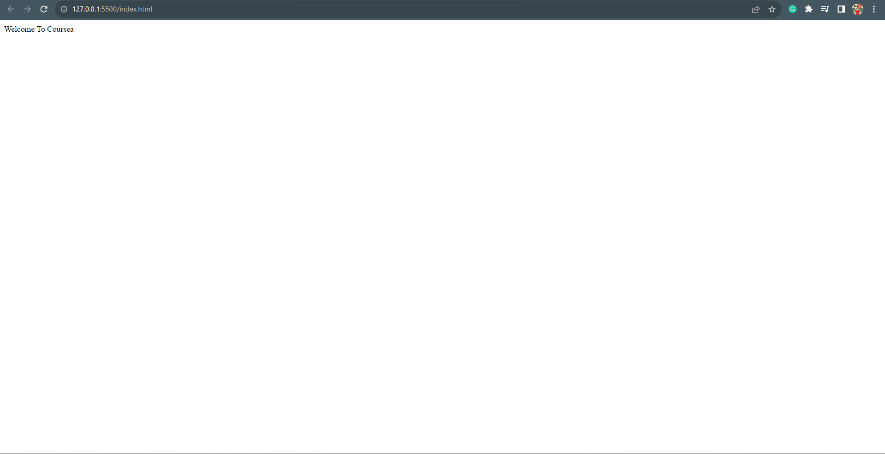

Login

<html lang="en">

<head>

    <meta charset="UTF-8">

    <meta name="viewport" content="width=device-width, initial-scale=1.0">

    <title>Login</title>

</head>

<body>

    <form action="">

        <label for="">Username</label>

        <input type="text" placeholder="Enter your Username">

        <br>

        <label for="">Password</label>

        <input type="text" placeholder="Enter your Password">

        <br>

        <button type="submit">submit</button>

    </form>

</body>

</html>

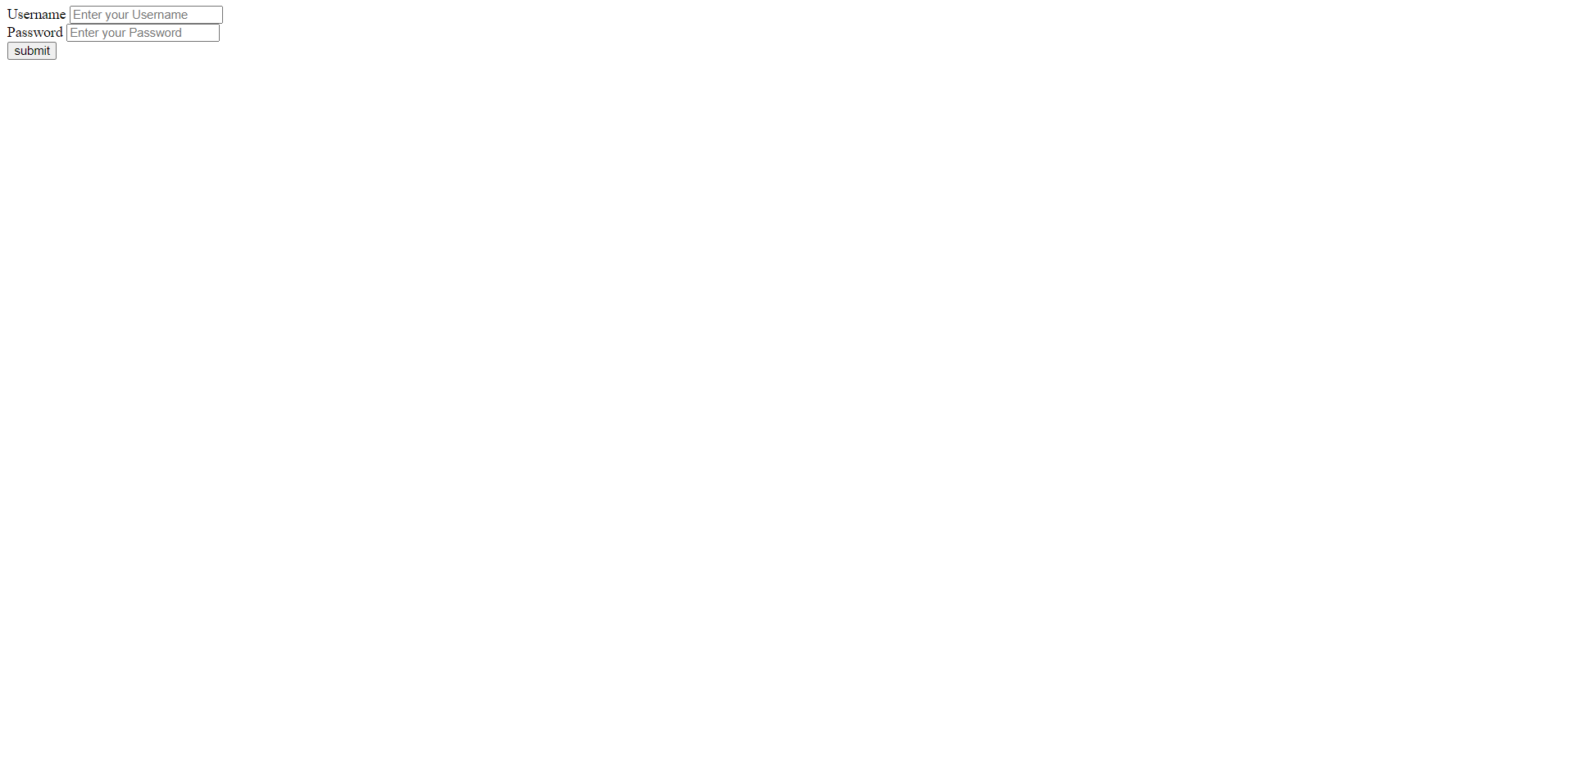

Signup

<html lang="en">

<head>

    <meta charset="UTF-8">

    <meta name="viewport" content="width=device-width, initial-scale=1.0">

    <title>signup</title>

</head>

<body>

    <form action="">

        <label for="">Username</label>

        <input type="text" placeholder="Enter your Username">

        <br>

        <label for="">Password</label>

        <input type="text" placeholder="Enter your Password">

        <br>

        <button type="submit">submit</button>

    </form>

</body>

</html>

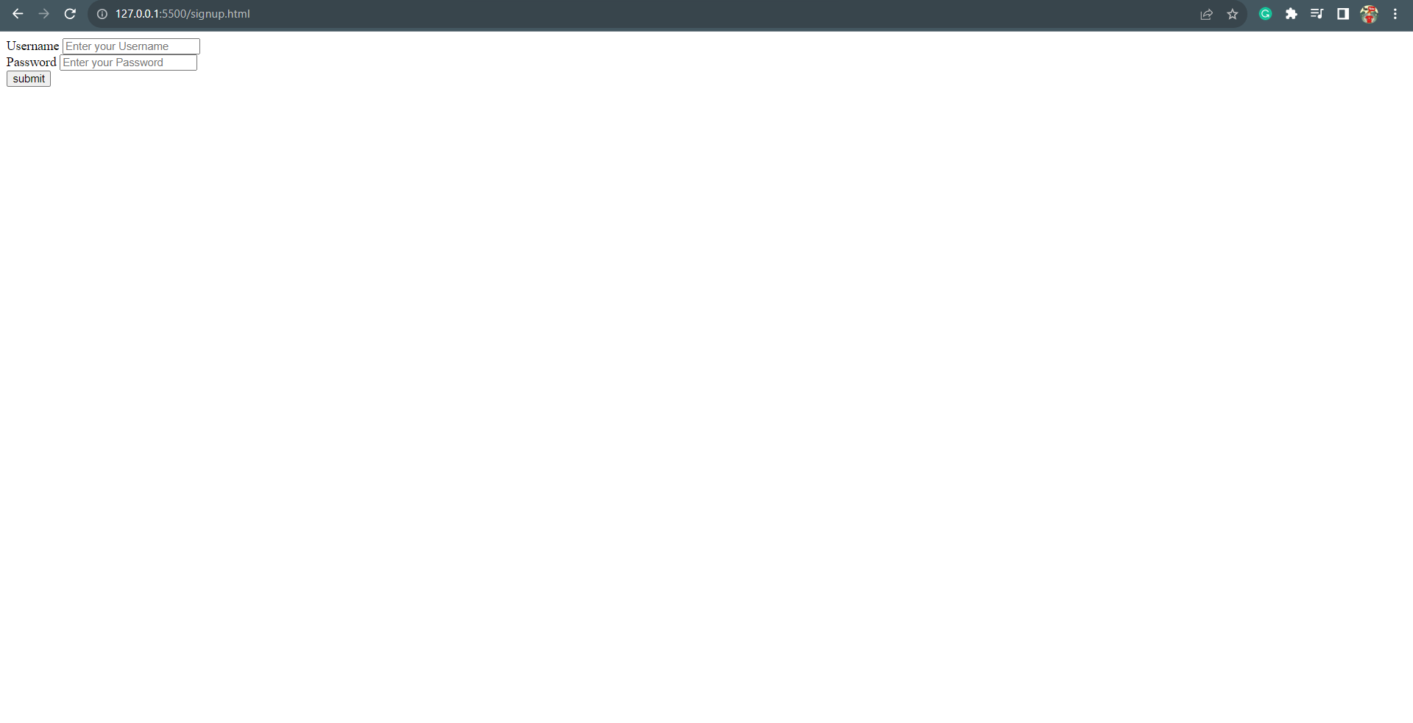

Your Courses

<html lang="en">

<head>

    <meta charset="UTF-8">

    <meta name="viewport" content="width=device-width, initial-scale=1.0">

    <title>Your Courses</title>

</head>

<body>

    <h1>Available Courses</h1>

    <div>

        <img src="https://dcblog.b-cdn.net/wp-content/uploads/2021/02/html.jpg" alt="Course Image">

        <h5>Introduction to HTML</h5>

        <p>Learn HTML in 100 minutes</p>

        <p>500$</p>

    </div>

</body>

</html>

